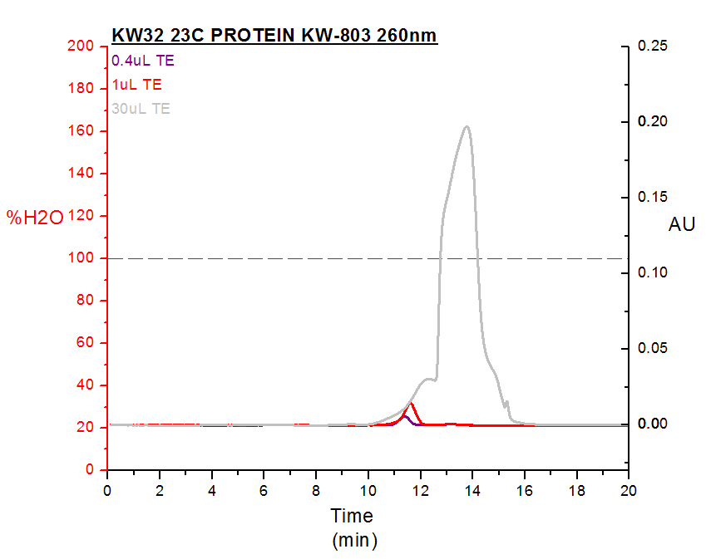Column: PROTEIN KW-803

Rate: 0.5ml/min

Elunt: H2O

Three runs at different concentration of TE. All samples are diluted to 100uL water before injection.

0.4uL TE: Concentration at injecting sample 40uM Tris, 4uM EDTA

1uL TE: Concentration at injecting sample 100uM Tris, 10uM EDTA

30uL TE: Concentration at injecting sample 3000uM Tris, 300uM EDTA

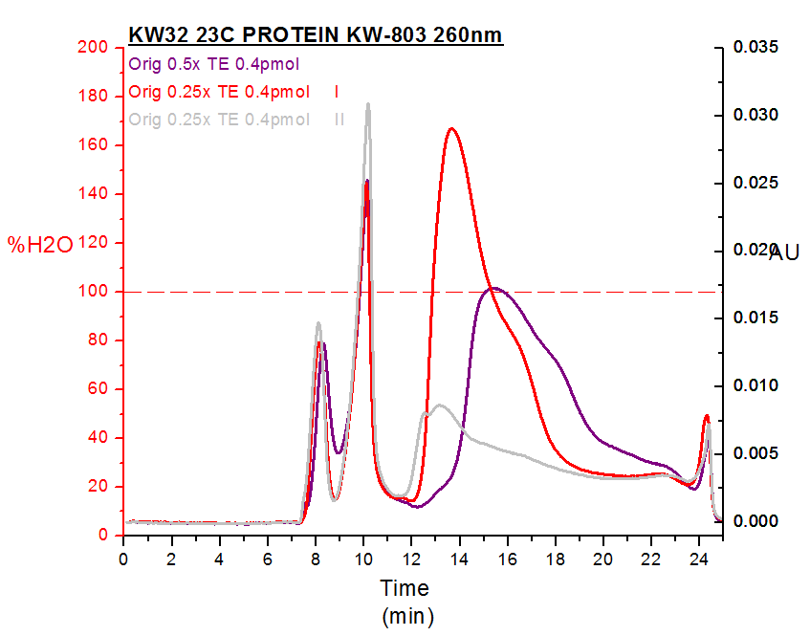Column: PROTEIN KW-803

Rate: 0.5ml/min

Elunt: H2O

Three runs at different concentration of TE. All samples are diluted to 100uL water before injection.

Orig 0.5x TE 0.4pmol: Concentration at injecting sample 0.4pmol DNA, 20uM Tris, 2uM EDTA

Orig 0.25x TE 0.4pmol: Concentration at injecting sample 0.4pmol DNA, 10uM Tris, 1uM EDTA